Rwanda

## Political Stability Estimate Data

The data set shows the political stability estimate of the country each year.

## # A tibble: 19 x 5  
## country iso3c date stability stabilityCategory4   
## <chr> <chr> <dbl> <dbl> <chr>   
## 1 Rwanda RWA 1996 -1.84 highly unstable   
## 2 Rwanda RWA 1998 -2.03 highly unstable   
## 3 Rwanda RWA 2000 -1.69 highly unstable   
## 4 Rwanda RWA 2002 -1.65 highly unstable   
## 5 Rwanda RWA 2003 -1.11 highly unstable   
## 6 Rwanda RWA 2004 -1.19 highly unstable   
## 7 Rwanda RWA 2005 -1.00 highly unstable   
## 8 Rwanda RWA 2006 -0.682 moderately unstable  
## 9 Rwanda RWA 2007 -0.358 moderately unstable  
## 10 Rwanda RWA 2008 -0.324 moderately unstable  
## 11 Rwanda RWA 2009 -0.506 moderately unstable  
## 12 Rwanda RWA 2010 -0.272 moderately unstable  
## 13 Rwanda RWA 2011 -0.177 moderately unstable  
## 14 Rwanda RWA 2012 -0.231 moderately unstable  
## 15 Rwanda RWA 2013 -0.111 moderately unstable  
## 16 Rwanda RWA 2014 -0.313 moderately unstable  
## 17 Rwanda RWA 2015 0.0132 moderately stable   
## 18 Rwanda RWA 2016 -0.0549 moderately unstable  
## 19 Rwanda RWA 2017 0.0392 moderately stable

## Political Stability Estimate Plot

The plot shows the trends of stabilization and destabilization for the each country.

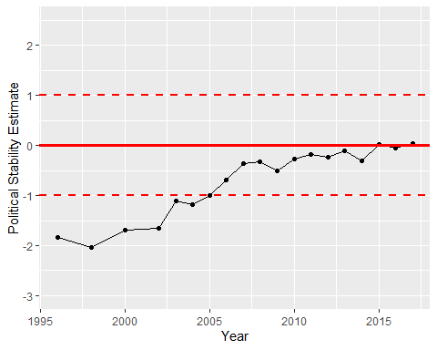

Political Stability Trend